* ***SUPPLY AND DEMAND STRATEGY***

*learning content…*

* *Introduction on Supply and Demand & (terms)*
* *Why Supply and Demand occur*
* *How to detect Supply and Demand Zone*
* *How to Apply Supply and Demand Zone On Chart*
* *Strong Price Turning points*
* *Entry with Supply and Demand*

**1. INTODUCTION TO SUPPLY AND DEMAND**

**-SUPPLY ZONE**

*Is the level/zone which or market maker, institutional banks are willing to sell,* *and this are the one who make the price to move in the market, in short are the one who make the movement of the price in the market.*

***LAW OF SUPPLY: the higher the price of something the more sellers are willing to sell it.***

**DEMAND ZONE -**

*Is the level /zone which or market maker or institutional banks are willing to buy and this are the one who make the price to move in the market, in short are the one who make the movement of the price in the market.*

***LAW OF DEMAND: the higher the price of something the less the buyers will buy it.***

* *Supply and demand + price action Are the one of the best strategies that as a trader you should use in your Analysis*
* *Note*

*Don’t think you can trade or you know how to trade within a short time. It will take time to master this strategy all you can do is trust the process……*

***PRACTICE MAKE PERFECT***

***WHY SUPPLY AND DEMAND OCCUR***

* *Because the banks have taken their profit of existing trades*
* *Because they have placed trades into the market*
* *Banks have trades left over which they need to get filled*
* *They occur to make reversals in the market*
* *This is the core of all strategies because it is direct from the economics*

**TEMINOLOGYS THAT WE USE IN SUPPLY AND DEMAND STRATEGY**

* **RALLY-** *this will show the movement of the market to go up (buy or bullish)*
* **DROP-** *this shows the movement of the market to go down (sell or bearish)*
* **BASE** *- this is the place where the market rest or consolidate for the short period of time*
* **PROXIMAL LINE-** *this is the line which we draw up or down of the candlestick*

*-proximal line (horizontal line which we draw up at the body of candlestick when we draw the demand line)*

*-Also, we draw Down of the body of candlestick when we draw supply level.*

***_CHRISSWONDER_***

* **DISTAL LINE-***this is the line that we draw to the lowest low or the highest high.*

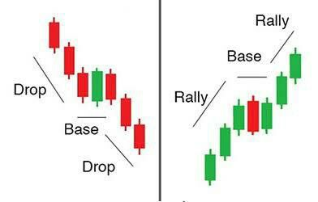

***Examples on those terms:***

1.SUPPLY LEVEL

2.DEMAND LEVEL

***_CHRISSWONDER_***

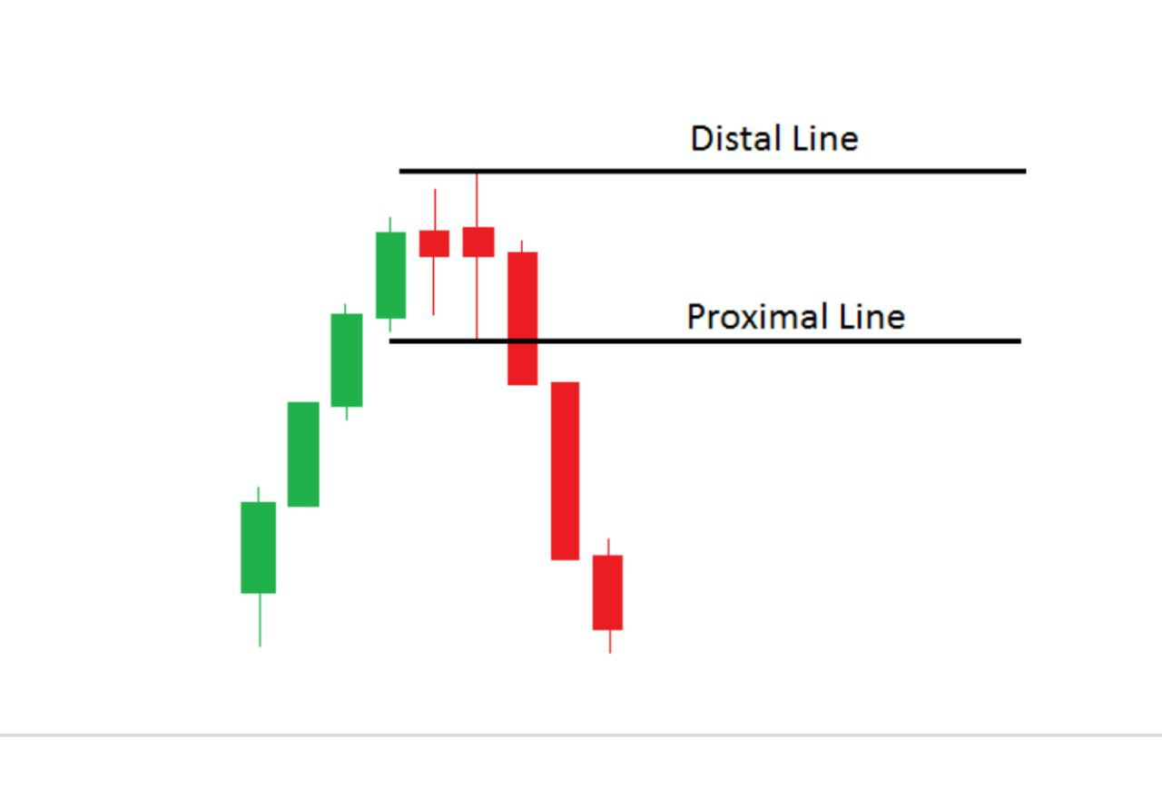

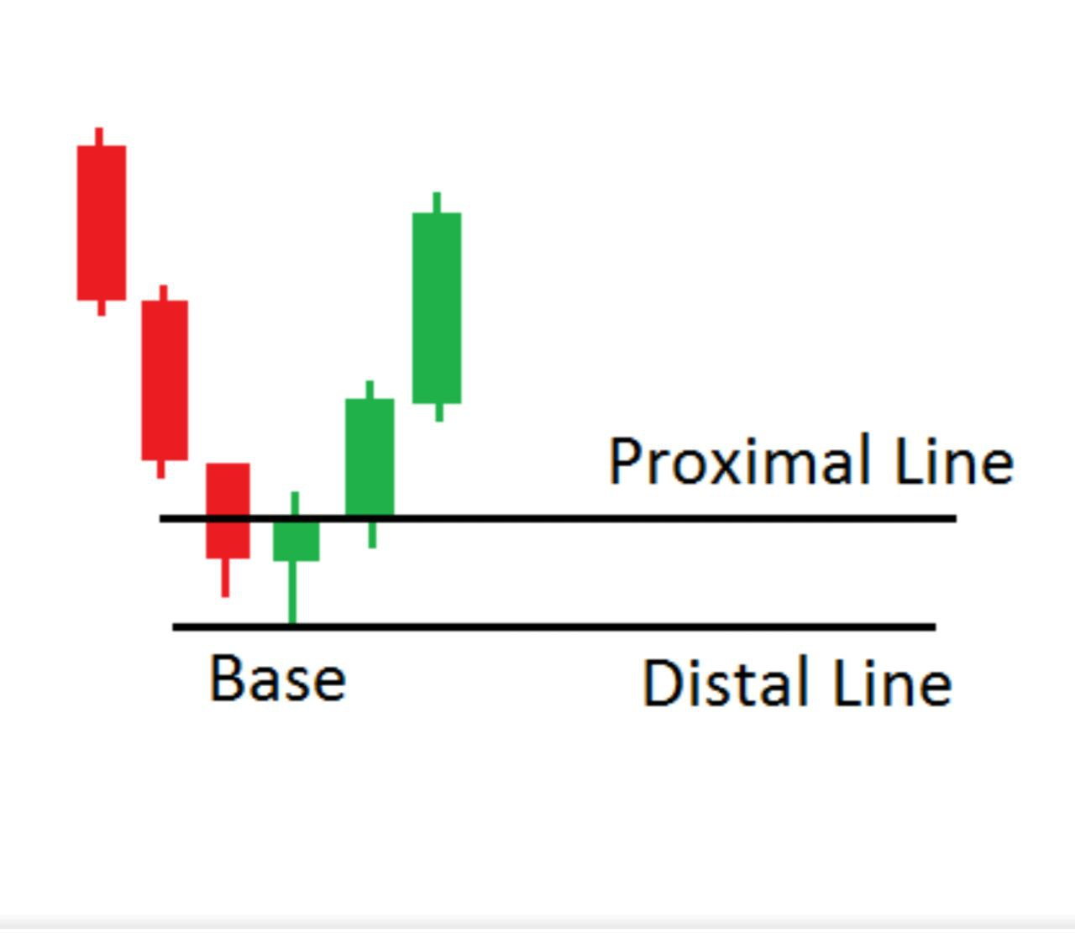

* **CONTINUATION PATTERN (CP)**

*This formed by Rally-base-Rally or Drop-base-Drop we get this on the time of trending market we use to get entry point in that time of trending market.*

**HOW TO DETECT AREAS WHERE IN SUPPLY  
DEMAND**

1. *By looking price which change direction (Valley & Peak)*

* **SUPPYL ZONE(PEAK)-***this is when price change the Direction from upward Movement and start to go Down (****RALLY-BASE-DROP)***

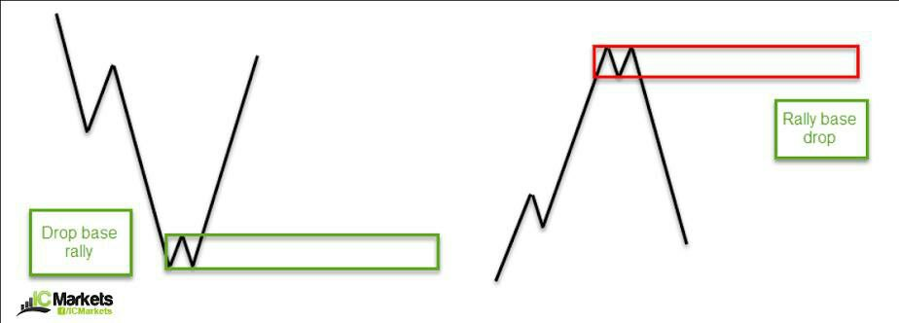

**NOTE: we Draw the supply zone at the base**

*Entry is when price comeback to the base*



* **DEMAND ZONE (VALLEY)-***this is when price change the direction from downside and start to go up*

***(DROP-BASE-RALLY)***



**NOTE: we draw the demand zone at the base**

*Entry is when price back to the base*

1. *To the place that price consolidation (CONTINUATION PATTERN)*

* *For supply zone it formed with* ***DROP-BASE-DROP***

***(DROP-BASE-DROP)*** *supply level it formed. And the Entry we get when the price comeback to retest at the zone formed.*

* *For Demand zone it formed with* ***RALLY-BASE-RALLY*** *Demand zone it formed. Entry point we get after the price comeback to retest the demand level*

_CHRISSWONDER_

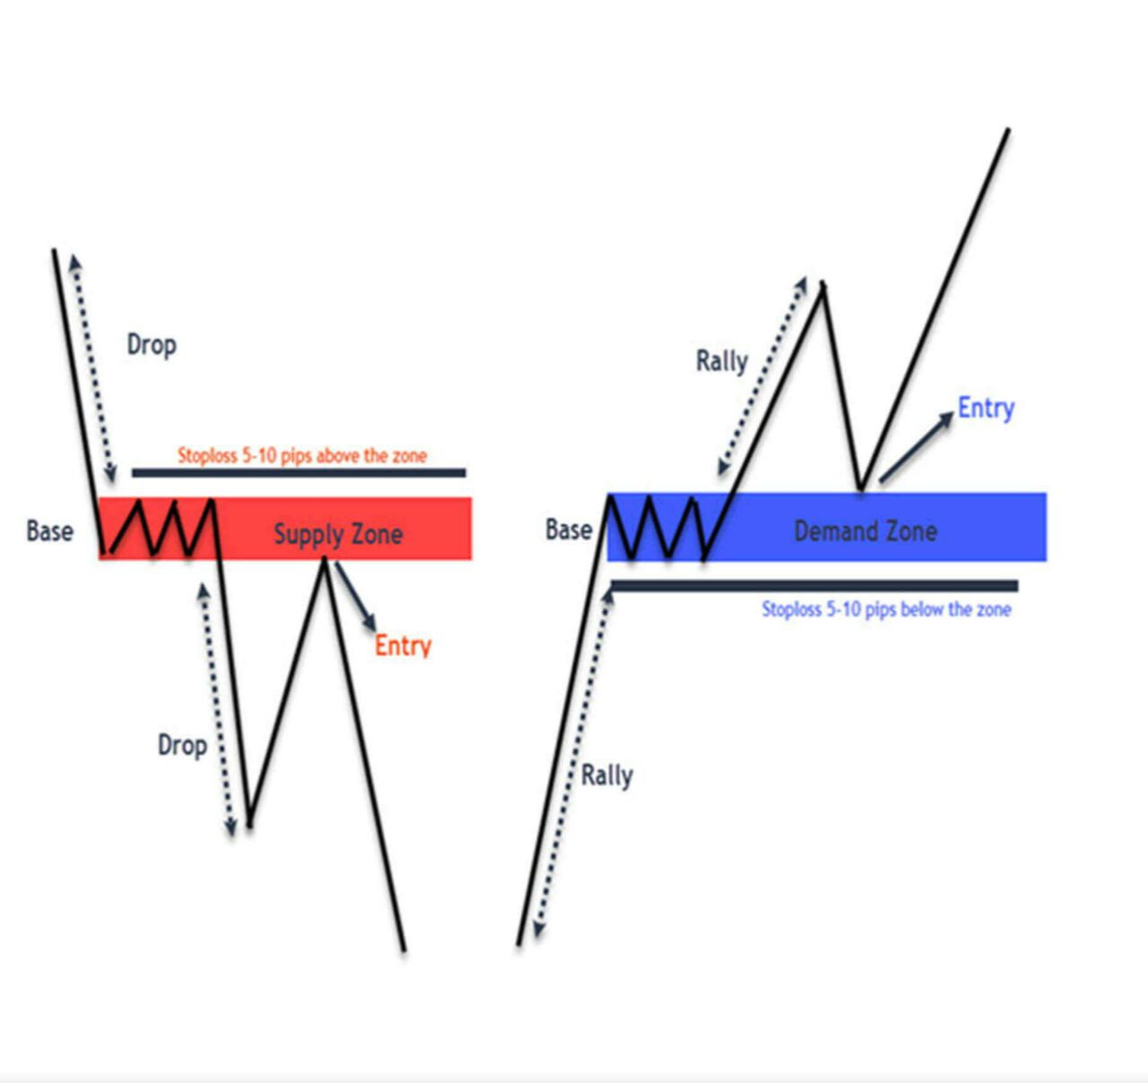

*_CHRISSWONDER_*

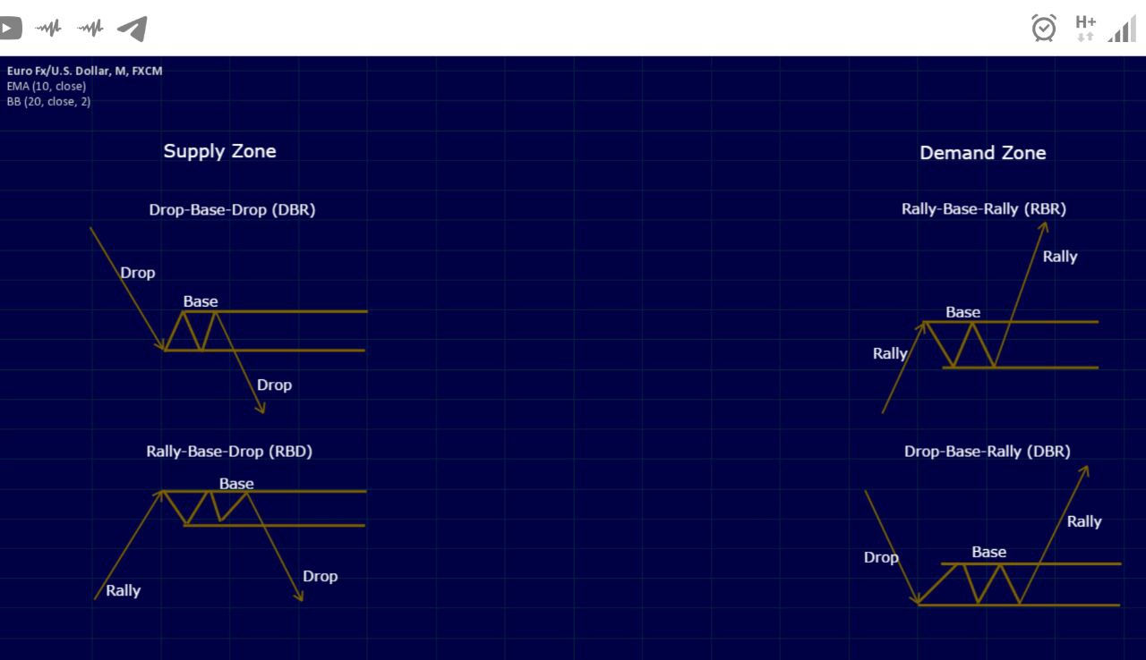

*THE BEST CONTINUATION PATTERN FORMED WHEN THE ERC CANDLE AT THE (RALLY-BASE-RALLY) or (DROP-BASE-DROP) WITH 50%*

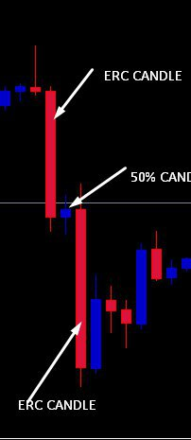

*Extended Range Candle (ERC)*

**HOW TO APPLY SUPPLY AND DEMAND ZONE**

**ON CHART**

*Supply and demand zone we indicate this by using* ***horizontal*** *line together with* ***rectangle.***

* *The point which price show the movement of the market goes down we call supply zone*

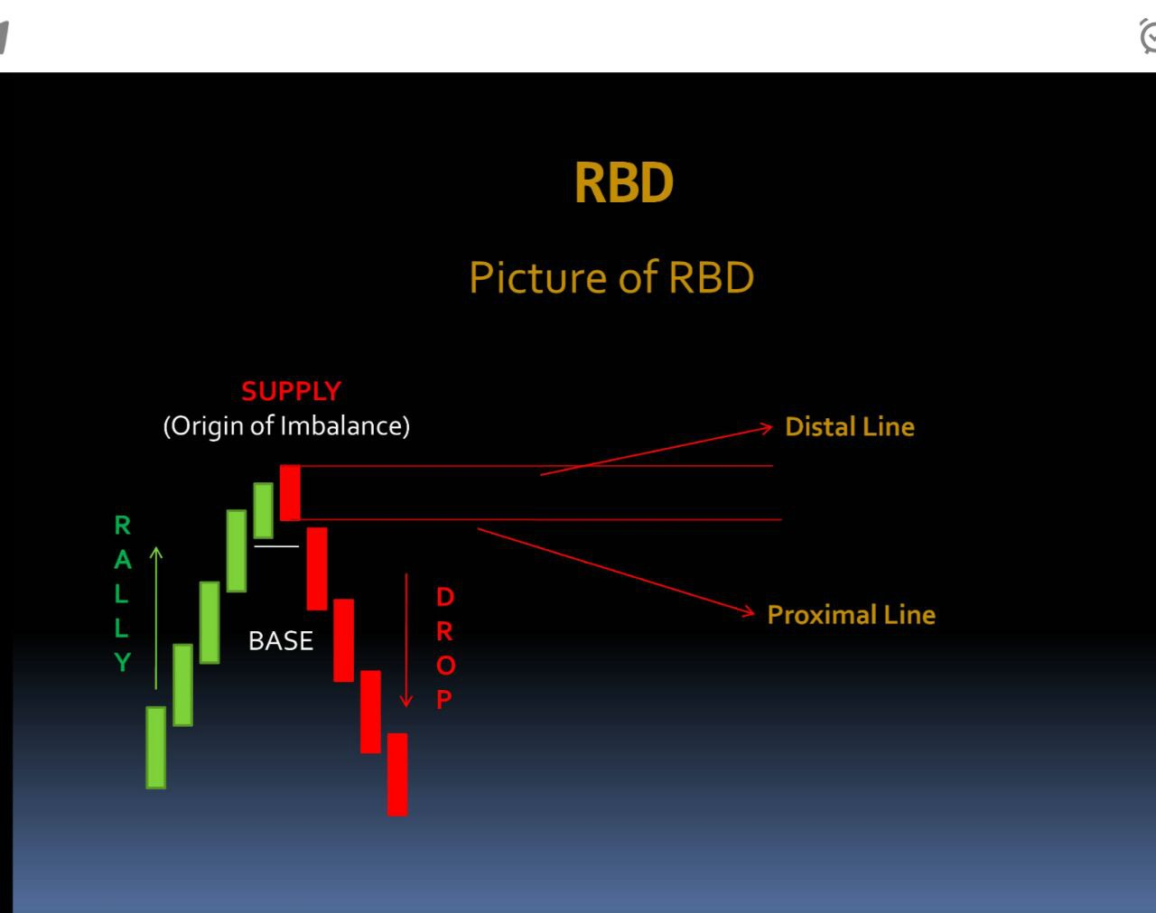

*Entry point is when price retest the base or zone*

* *The point in which price shows the movement of the market goes up we call demand zone*



*Entry point is when the price back to retest the base or the zone*

**STRONG PRICE TURNING POINTS**

*Whether we look at strong price turning points trend or support and resistance areas there is concept of supply and demand trading is always at the core of it.*

* **FRESHNESS,** if you trade supply and demand always make sure the zone is still fresh which means that the initial creation of the zone price has not come back to it yet.
* **TIMELY EXIT,** *Good supply or demand Do not* *hold too long. A shorter accumulated zone works better.*
* **STRONG FORCE LEAVING THE ZONE,** *this point is important. The stronger the breakout or the move of the price from the base the better the demand or supply zone.*
* **AMATEUR SQUEEZE,** *the DROP-BASE-RALLY with RALLY-BASE-DROP this shows that the level or the zone where to buy or to sell interest go so great.*
* **THE SPRING,** *“the spring pattern looks like a false breakout after the fact but when it happens it trap trades into taking trades into the wrong direction. This pattern used by professionals to acquire large position”.*

**ENTRIES WITH SUPPLY AND DEMAND**

**There are two types of entries**

1. ***AGGRESSIVE ENTRY***
2. ***CONSERVATIVE ENTRY***

* **AGGRESSIVE ENTRY***, this is the type of entry which means after price comeback to retest to the zone without waiting for any signal*
* **CONSERVATIVE ENTRY,** *is the entry which price back to the zone we wait for signal*

*(Signal always is formation of candlestick pattern) doji, engulfing, pin bar, inside bar etc.……*

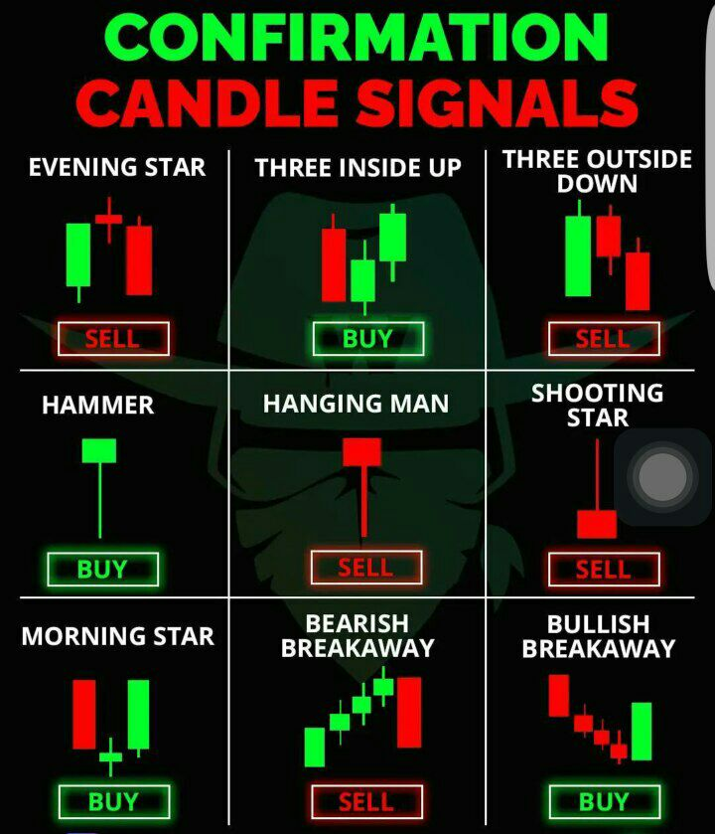

***_CHRISSWONDER_***

***THE STRUCTURE AND NATURE OF THE MARKET***

* **Market structure**

*To understand the market structure, we must first understand that the market has a continuous cycle which is a series of consecutive corrections and impulses in a 1-2-3 formation (Impulse-correction-Impulses). In simple form structure is the use of two types of market so as to understand the next movement of the next market breathing cycle.*

**TYPES OF MARKET**

Through your price action analysis, you will experience two types of market, trending market, Ranging market

1. *Trending market*
2. *Ranging market*

* ***Trending market***

*Trending market are simply characterized by repeating pattern of higher high and higher low in an uptrend*

*Market and Lower high and lower low in down trend market.*

*See example below Uptrend*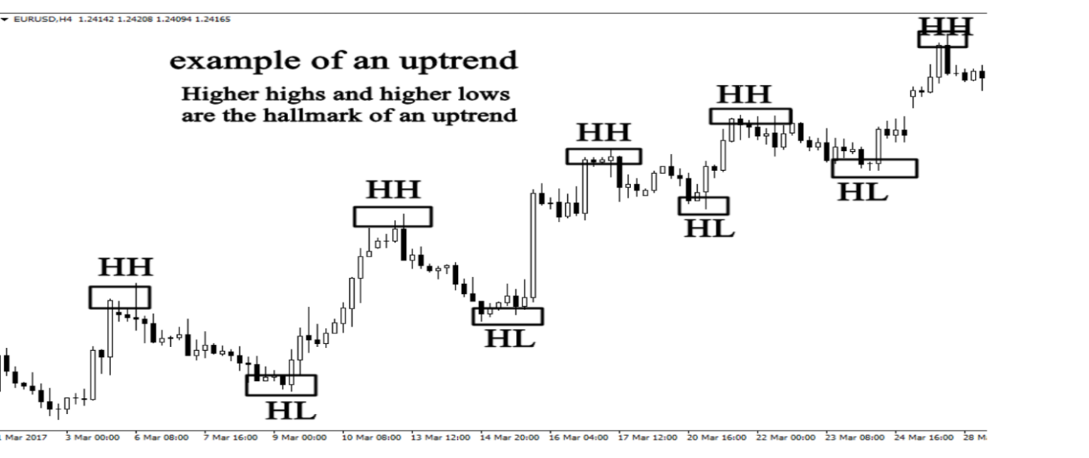

*See another example of* ***downtrend***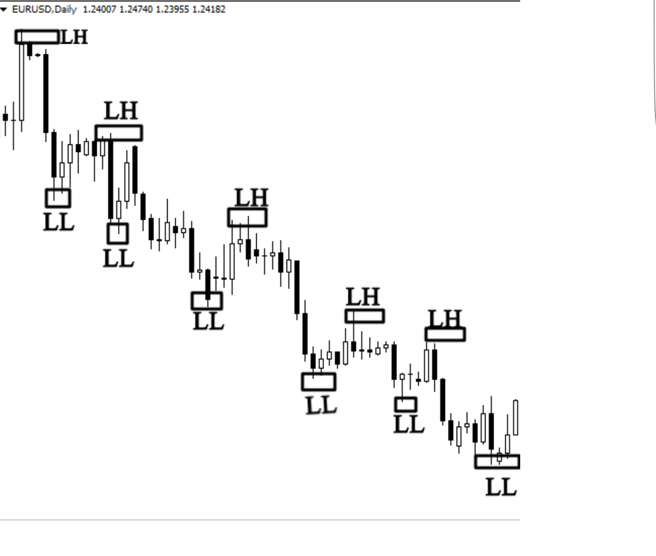

*Trending market are easy to identify, do not try to complicate your analysis use your brain and see what the market is doing.*

*To determine whether a market is trending or not you have to use bigger timeframes such the 4H, D1 and Weekly TF never try to use smaller Timeframe to determine the structure.*

* ***Ranging market***

*Ranging markets are pretty straight forward, they are often called side way market, because they horizontally or they neutral nature makes them appear to drift to the right. In the ranging market there is support and resistance levels where buyers and sellers knocking between support and resistance level.*

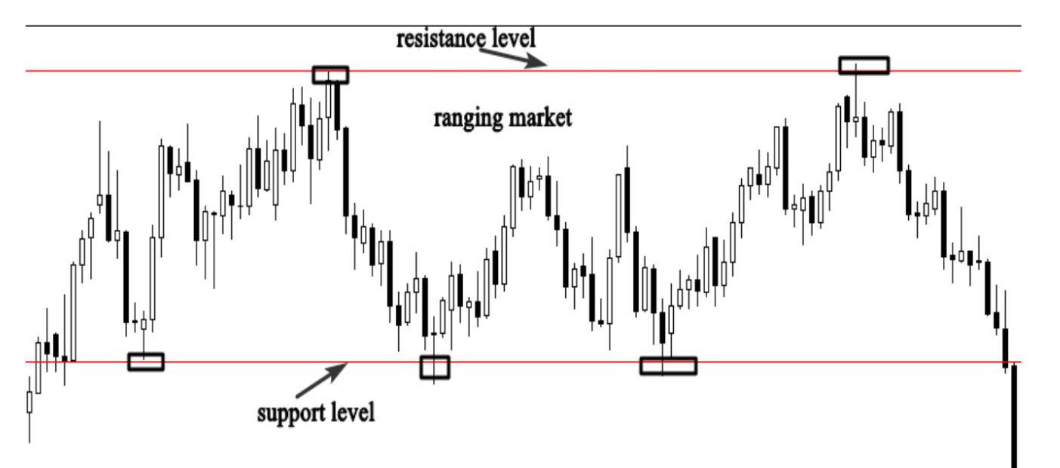

*This analysis will help you identify if the market is trending up or down or ranging. In general, you will know what big investors are going. And you will try to find a way to follow them on the smaller timeframe.*

***NATURE OF THE MARKET***

*“What the nature telling us”*

*We use nature always to look at the characteristics of price action. There are two types of nature in the market which are Impulsive phase and corrective phase. We use our understanding of impulsive and corrective nature to determine when a possible continuation or reversal is taking place.*

* *IMPULSIVE PHASE*
* *CORRECTIVE PHASE*
* ***IMPULSIVE PHASE-****The nature of an impulsive phase is a set of large momentum candles*
* ***CORRECTIVE PHASE****The nature of corrective phase is a set of stagnant candlesticks moving side ways*

*As we said market has a continuous cycle which is a series of consecutive correction and impulsive (impulsive-correction-impulsive).*

*The corrective phase is normally counter trend where the impulsive phase is normally moving in direction of the trend (with trend) and in the direction of the impulsive that took place before the correction phase.*

*Naturally if the correction took the shape of continuation the next impulsive will be with the trend. However if the correction took the shape of reversal then the next impulse will be in the opposite direction to the trend*

*See the example below*

